Project Report
Adjustable DC Power Supply Unit (PSU)
Name: Tirth kushwaha
Class: SE E&TC A 48
1. Objective
The objective of this project is to design and construct a safe and adjustable DC power supply using the LM317 adjustable voltage regulator. The power supply converts AC mains voltage into a regulated DC output that can be varied between approximately 1.25 V and 21 V. It can be used to power small electronic circuits, prototype boards, and hobby electronics.
2. Components Used and Their Purpose
S.No | Component | Value / Rating | Purpose
1 | Step-down Transformer | 0–15 V AC, 3 A | Steps down mains voltage to safe low AC voltage
2 | Fuse | 2 A / 250 V | Protects the circuit from overcurrent
3 | Power Switch | SPST | Allows safe ON/OFF control
4 | Bridge Rectifier Module | 4‑pin rectifier module | Converts AC voltage into DC voltage
5 | Filter Capacitor | 4700 µF / 50 V | Smooths rectified DC and reduces ripple
6 | LM317 Voltage Regulator | 1.5 A adjustable | Provides regulated adjustable output voltage
7 | Resistor R1 | 220 Ω | Sets reference voltage for LM317
8 | Potentiometer R2 | 10 kΩ | Adjusts the output voltage
9 | Output Capacitor | 2.2 µF / 25 V | Stabilizes the output voltage
10 | Digital Voltmeter | 1–30 V DC | Displays output voltage
11 | Heat Sink | — | Prevents overheating of the LM317
12 | Protection Diode (optional) | 1N4007 | Protects load from back EMF

3. Circuit Explanation
The circuit consists of several stages that convert AC mains power into regulated DC output.
AC Input Stage: A step‑down transformer reduces 220 V AC mains voltage to 15 V AC, making it safe for electronic circuits.
Protection Stage: A fuse protects the circuit from overcurrent, while a power switch allows the PSU to be turned ON or OFF safely.
Rectification Stage: The AC voltage is converted to DC using a bridge rectifier module containing four internal diodes arranged in a bridge configuration.
Filtering Stage: A 4700 µF capacitor smooths the pulsating DC and reduces ripple voltage.
Voltage Regulation Stage: The LM317 adjustable voltage regulator provides a stable output voltage.
Output Stabilization: A 2.2 µF capacitor at the output improves voltage stability and reduces noise.
Voltage Measurement: A digital voltmeter is connected to display the output voltage of the PSU.
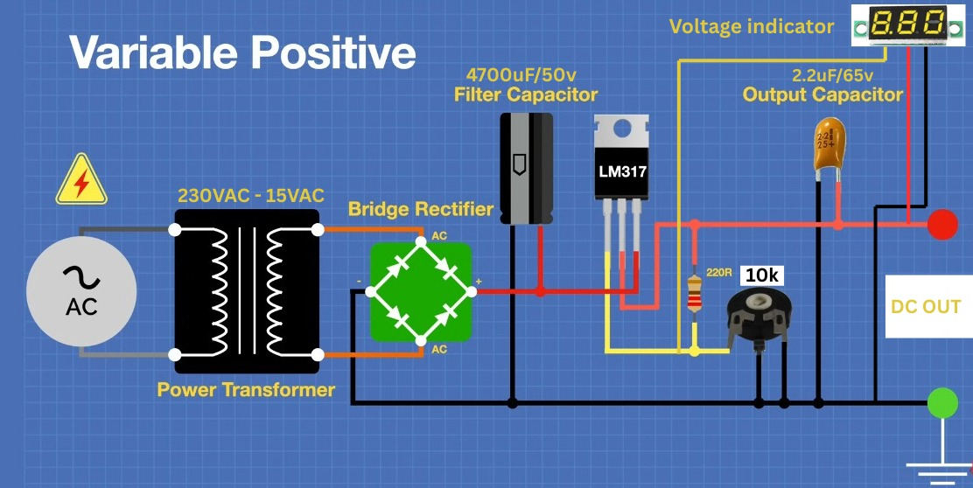

Reverse Voltage Protection Circuit
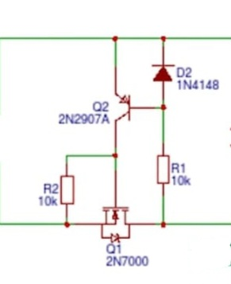
To improve the safety and reliability of the power supply, a reverse voltage protection circuit was added at the output stage. The circuit uses a 2N7000 N-channel MOSFET (Q1), a 2N2907A PNP transistor (Q2), a 1N4148 diode (D2), and biasing resistors.
Working Principle:
- During normal operation, when the output polarity is correct, Q1 and Q2 are biased appropriately, allowing current to flow to the load with very low voltage drop.
- If the output terminals are accidentally connected in reverse polarity, the transistor network immediately turns OFF the conduction path.
- The load is isolated from the power supply, preventing damage to sensitive electronic circuits.
- The 1N4148 diode provides additional protection and helps control the transistor switching action during polarity reversal.
- Unlike a conventional series diode, this circuit introduces negligible voltage loss during normal operation, maintaining better efficiency and voltage regulation.
Advantages:
- Protects connected circuits from accidental reverse polarity connections.
- Low power dissipation compared to diode-only protection.
- Minimal voltage drops across the protection stage.
- Improves the overall robustness and reliability of the PSU.
Application in this Project:
The reverse voltage protection circuit was incorporated into the adjustable LM317 power supply to prevent damage to external circuits and components in case of incorrect output connections, making the PSU safer for laboratory and prototyping use.
Component | Value | Purpose
2N7000 MOSFET | 2N7000 | Reverse polarity protection
PNP Transistor | 2N2907A | Controls protection action
Diode | 1N4148 | Switching and polarity sensing
Resistors | 10 kΩ | Biasing network for transistors

4. Maximum Output Voltage Calculation
The approximate DC voltage after rectification can be estimated using the formula:
Vdc ≈ Vac × 1.414 − 2Vdiode
For a 15 V transformer:
Vdc ≈ 15 × 1.414 − 2 ≈ 21 V

5. Voltage Adjustment
The LM317 regulator allows the output voltage to be adjusted using a resistor and a potentiometer. The output voltage is determined by the formula:
Vout = 1.25 × (1 + R2/R1)
Where R1 = 220 Ω and R2 = 10 kΩ potentiometer.

6. Observations / Measurements
Measurement | Value
Minimum Voltage | 1.25 V
Maximum Voltage | 21.6 V
Voltmeter Reading | ~1 V lower than multimeter
Load Test | DC motor works safely up to 12–15 V

7. Safety Precautions
Do not touch mains wires when the circuit is powered.
Always use a fuse to protect the circuit.
Ensure correct polarity of electrolytic capacitors.
Use a heat sink for the LM317 regulator.
Switch OFF power before modifying connections.

8. Conclusion
The adjustable DC power supply was successfully designed using the LM317 voltage regulator. The circuit provides a stable adjustable output from approximately 1.25 V to 21 V. This project demonstrates the concepts of rectification, filtering, voltage regulation, and basic protection techniques used in power supply design.

